**Test Plan Name: Buy some energy**

Table of Contents

1.0 Test Script Details 2

2.0 Revision History 2

3.0 Test Scope 3

4.0 Test Execution Entry Criteria 3

5.0 Execution Details 4

6.0 Test Steps 5

Observations 9

o Observation 1 9

o Observation 2 10

o Observation 3 11

o Observation 4 12

o Observation 5 13

# 1.0 Test Script Details

|  |  |
| --- | --- |
| **Test Script ID:** | 001 |
| **Test Script Name:** | QA Exercise_Buy_some_energy_v1.0 |
| **Authored By:** | Vijay Kumar |
| **Reviewed By:** | ENSEK Team member |

# 2.0 Revision History

|  |  |  |  |
| --- | --- | --- | --- |
| **Name** | **Modifications** | **Date** | **Version** |
| Vijay Kumar | Document Creation | 20-JUL-2023 | 1.0 |

# 3.0 Test Scope

|  |  |
| --- | --- |
| Test Scope | * Buy some energy cover below requirements |
| Requirement Coverage | * Req_01 * Req_02 |

# 4.0 Test Execution Entry Criteria

|  |  |
| --- | --- |
| Test Execution Entry Criteria/  Definition of Done (DoD) | * Acceptance Criteria for “Buy some energy” functionality is demoed and accepted. * Requirements document is signed off. * Test Script reviewed and signed off. * Latest stable build is deployed to QA or Formal environment. |

# Execution Details

|  |  |
| --- | --- |
| **Post-Test Signatures** | |
| Tested By | Vijay Kumar, Sr. Test Engineer |
| Tester Signature&  Date (DD-MMM-YYYY) | Vijay Kumar & 20-JUL-2023 |
| Reviewed By | ENSEK Team Member, Test Lead |
| Reviewer Signature & Date (DD-MMM-YYYY) |  |
| Run Number: | 1 |
| Build Number: | 1234 |
| Browser & Version | Chrome & Version 114.0.5735.199 (Official Build) (64-bit) |
| Operating System &Version | Windows 10 & 10.0.19045 N/A Build 19045 |

|  |  |
| --- | --- |
| **Test Script Result** | **Comments** |
| ☐ Pass  ☒ Fail  ☐ Blocked | Below defects are logged in JIRA and assigned to BA/PO for triage.   * DE123 * DE124   More observations are document from Pages 9-13. |

# 6.0 Test Steps

| **Step #** | **Action(s)** | **Expected Result(s)** | **Test Status** | **Actual Results /Notes** |
| --- | --- | --- | --- | --- |
| **Test Objective: Positive scenarios for “Buy some energy – GAS Energy Type”** | | | | |
|  | Launch  <https://ensekautomationcandidatetest.azurewebsites.net/>  and click on “Buy energy” button under “Buy some energy” section | Buy energy page is displayed successfully  i.e. <https://ensekautomationcandidatetest.azurewebsites.net/Energy/Buy>  **[Take Objective evidence]** | **☑** Pass  ☐ Fail  ☐ Blocked |  |
|  | Make a note of “Quantity of Units Available “ for all Energy Types  Click “Reset” button | Quantity of Units Available for all Energy Types are displayed as noted in “Actual results/Notes” column.  i.e. display default values | **☑** Pass  ☐ Fail  ☐ Blocked | Gas = 3000 Units  Nuclear = 0 Units  Electricity = 4322 Units  Oil = 20 Units |
|  | Buy Gas with “Number of Units Required**” is equal to** “Quantity of Units Available “ | Below message is displayed on “Sales Confirmed!” page  Thank you for your purchase of 3000 units of Gas We have popped it in the post and it will be with you shortly.  There are now 0 units of Gas left in our stores.  **[Take Objective evidence]** | **☑** Pass  ☐ Fail  ☐ Blocked |  |
|  | **Reset the Values**  Buy Gas with “Number of Units Required” **less than** (e.g. 1000 units) “Quantity of Units Available” | User should be able to view below message on “Sales Confirmed!” page  Thank you for your purchase of 1000 units of Gas We have popped it in the post and it will be with you shortly.  There are now 2000 units of Gas left in our stores | **☑** Pass  ☐ Fail  ☐ Blocked |  |
|  | Buy more Gas with “Number of Units Required” **less than** (e.g. 1000 units) current “Quantity of Units Available” | User should be able to view below message on “Sales Confirmed!” page  Thank you for your purchase of 1000 units of Gas We have popped it in the post and it will be with you shortly.  There are now 1000 units of Gas left in our stores | **☑** Pass  ☐ Fail  ☐ Blocked |  |
|  | Buy more Gas with “Number of Units Required” **less than** (e.g. 1000 units) current “Quantity of Units Available” | User should be able to view below message on “Sales Confirmed!” page  Thank you for your purchase of 3000 units of Gas We have popped it in the post and it will be with you shortly.  There are now 0 units of Gas left in our stores. | **☑** Pass  ☐ Fail  ☐ Blocked |  |
| **Test Objective: Negative scenarios for “Buy some energy – GAS Energy Type”**  **Note:**   * + - 1. Couple of scenarios are covered as part of the excersie. Other scenarios includes boundary values, alphanumeric, cross site scripting (XSS) attack etc.       2. Requirements document is NOT shared for buy energy functionality and currently exception is thrown for these scenarios**, “**Expected Results” are written as per industry standards. | | | | |
|  | Launch <https://ensekautomationcandidatetest.azurewebsites.net/Energy/Buy>  Buy Gas with “Number of Units Required” field with non-numeric values  (e.g. A or * or --) | Below error message is displayed  “Number of Units Required” must be numeric value.  **[Take Objective evidence]** | ☐ Pass  **☒** Fail  ☐ Blocked | Error page is displayed with below exception details  see screenshot and log file for details      **DE123** is logged in JIRA |
|  | Launch <https://ensekautomationcandidatetest.azurewebsites.net/Energy/Buy>  Buy Gas with “Number of Units Required” field with blank value  i.e. remove 0 corresponding to Gas energy type | Below error message is displayed  “Number of Units Required” must not be blank.  **[Take Objective evidence]** | ☐ Pass  **☒** Fail  ☐ Blocked | Error page is displayed with below exception details  see screenshot and log file for details      **DE124** is logged in JIRA |
| **END OF TEST SCRIPT** | | | | |

# Observations

## Observation 1

* Text size is not same for the lines highlighted below.
* Period (.) is missing from all the 3 lines highlighted in below screenshot

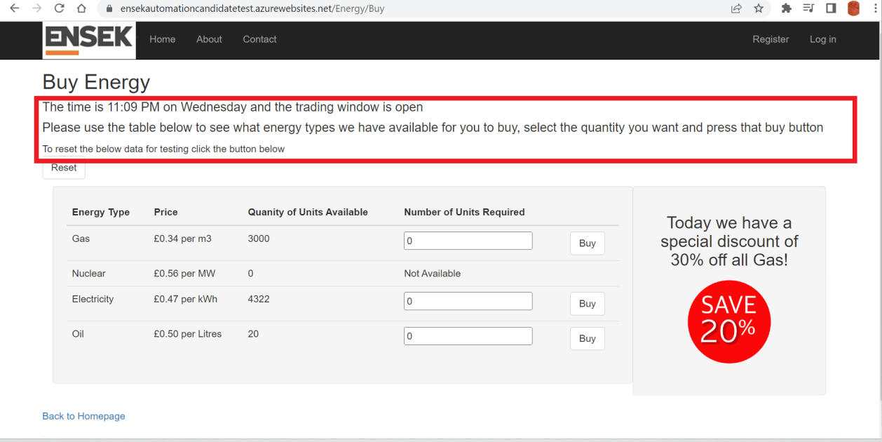

## Observation 2

* Typo error: Quanity instead of Quantity
* Units Available and Units Required column labels should be consistent
  + **Quantity** of Units Available and **Quantity** of Units Required **or**
  + **Number** of Units Available and **Number** of Units Required

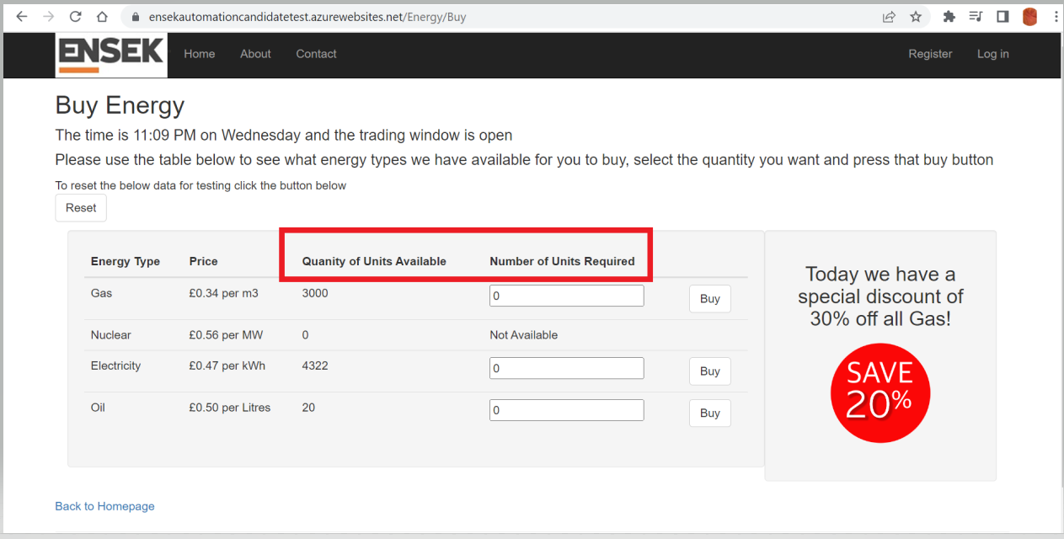

## Observation 3

* Discrepancy in discount % in text and image i.e. 30% in text and 20% in image
* Discount section is not properly aligned with energy details section.

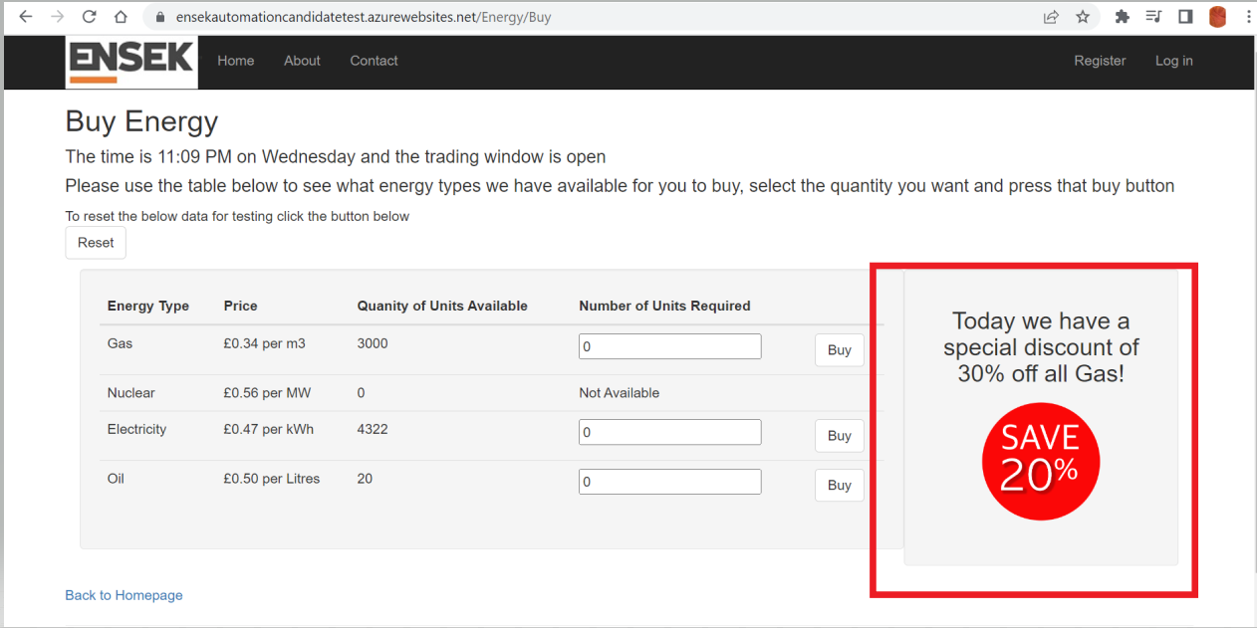

## Observation 4

* Row size for each energy type are NOT same
* Quantity of Units Available and Number of Units Required column labels should have wrapped for better view
* Number of Units Required text box size should have restricted to 4 digits. Also validations are missing on non-numeric & blank values.

(Currently throw error/exception)

* Buy “Number of Units Required” with ‘0’ & negative value should be restricted.

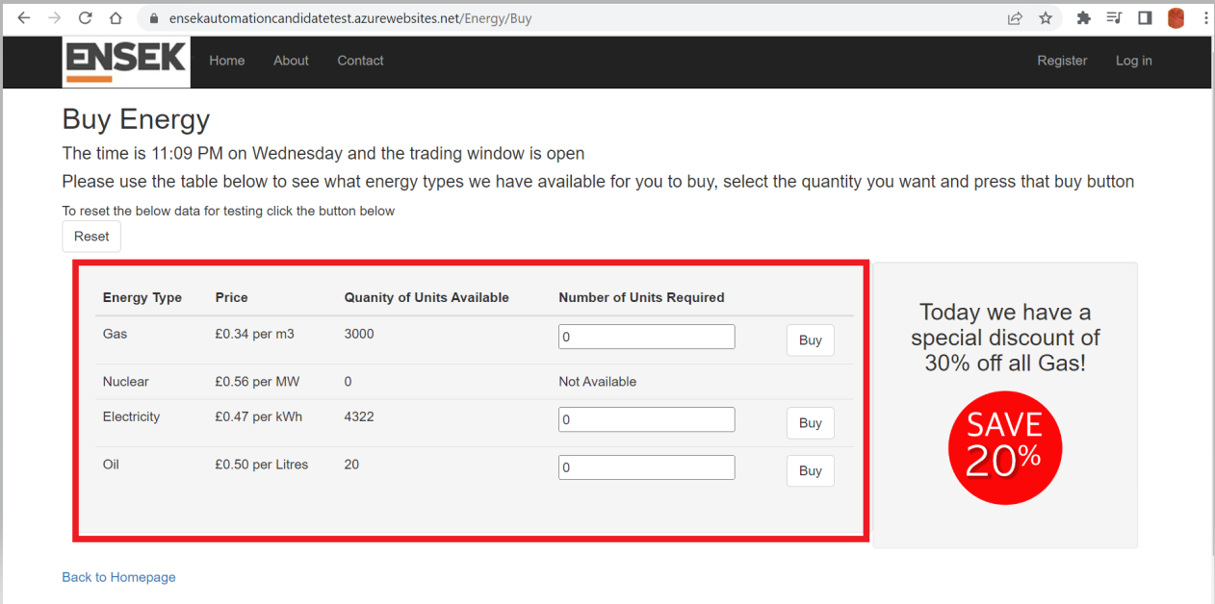

## Observation 5

* If Zero units are available for energy type, **Buy more** button shouldn’t be displayed. button to navigate back to “Buy Energy” page will be intuitive

